Laws of Operations- How do these make maths easier

The “Distributive Law"
- allows us to break up a hard multiplication into easier pieces and then add the answers together to get the solution.
14 x 6 = 10 x 6 + 4 x 6
= 60 + 24
= 84

The "Associative Law"
- it doesn't matter which we calculate first we get the same answer
- only all addition or all multiplication).
- This helps so we can do the easy ones first.
EXAMPLE;

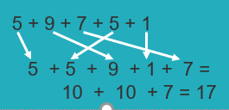
The "Commutative Law"
- we can swap numbers around and still get the same solution
- only for addition or multiplication
EXAMPLE;
8 + 6 = 6 + 8 Both = 14 3 x 5 = 5 x 3 Both = 15
Laws of Operations- How do these make maths easier

